**Task – 9**

**Docker Volume and network:**

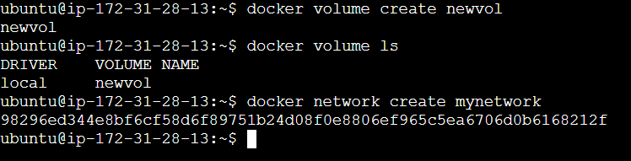

**Docker File:**

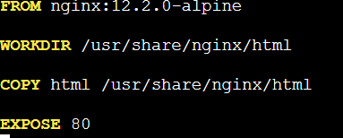

**Docker Compose**

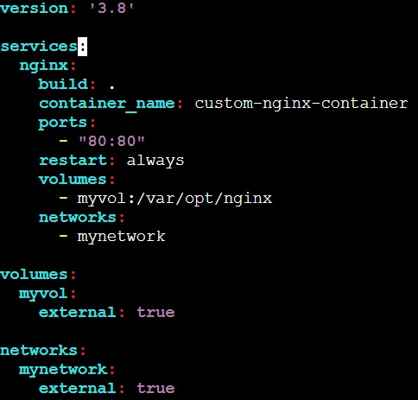

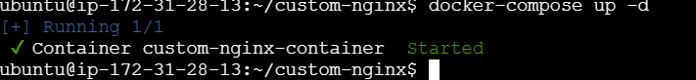

**Custom volume and network:**

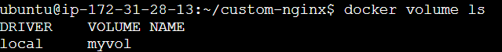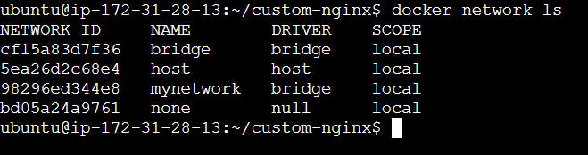

**Docker Login:**

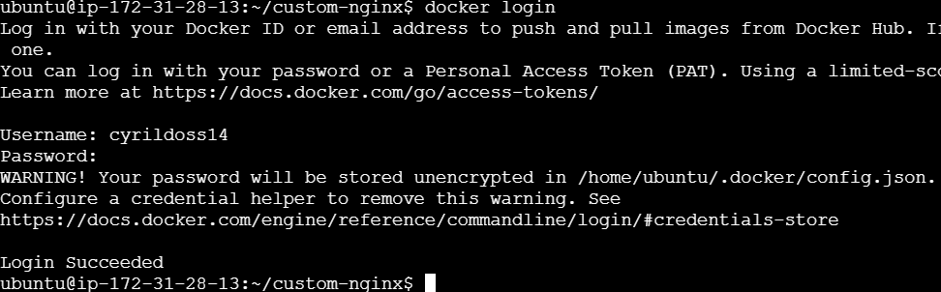

**Docker Tag and Push:**



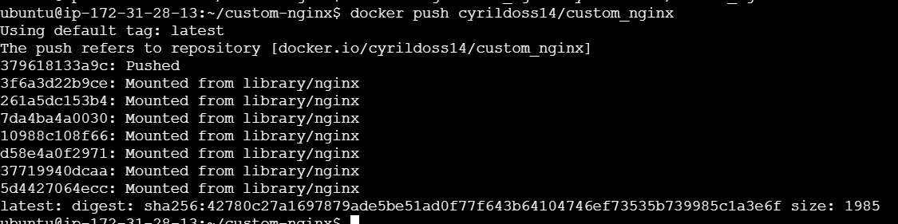

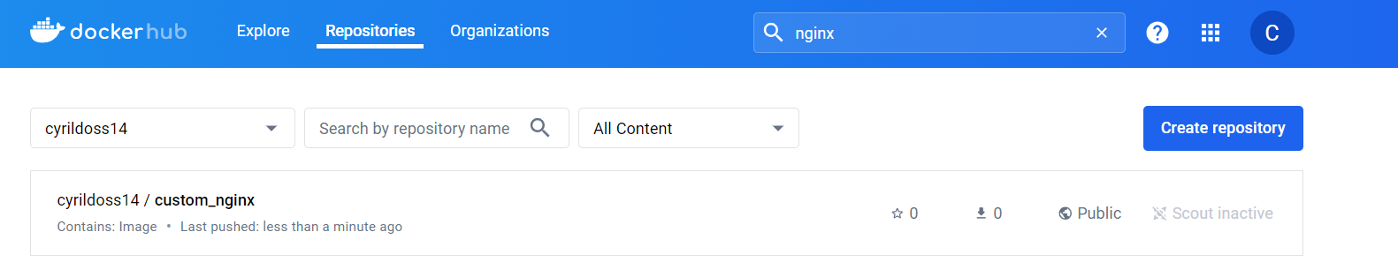

**Output:**

